SOCIAL MEDIA TOOLKIT EXAMPLES
The following sample posts have been extracted from a larger toolkit.

Example 1
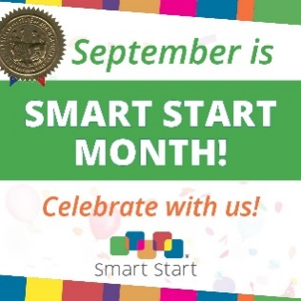
Text:
𝗦𝗲𝗽𝘁𝗲𝗺𝗯𝗲𝗿 𝗶𝘀 𝗦𝗺𝗮𝗿𝘁 𝗦𝘁𝗮𝗿𝘁 𝗠𝗼𝗻𝘁𝗵! 𝗖𝗲𝗹𝗲𝗯𝗿𝗮𝘁𝗲 𝘄𝗶𝘁𝗵 𝘂𝘀!
We are a network of 75 Local Partnerships serving all 100 counties.
We provide whole-child support from birth-to-five. We invest in early care and education, family support, and healthy families and communities.
By supporting young children and their families, we are building a stronger, healthier future for North Carolina.
Celebrate with us and learn how Smart Start is making a difference in your community!

Example 2
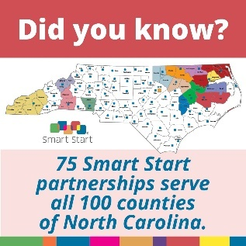
Text:
𝗗𝗶𝗱 𝘆𝗼𝘂 𝗸𝗻𝗼𝘄? [LOCAL PARTNERSHIP NAME] is proud to be one of 75 Smart Start partnerships across North Carolina! Our Network is present in every community, ensuring that no matter where families are, a Smart Start partnership is always nearby to support them.
Here in [COUNTY/COUNTIES NAME] we served [NUMBER OF CHILDREN] through programs like [LIST OUT PROGRAMS RELATED TO THE DATA POINT].
Learn more about how the Smart Start Network is working across the state to support every child 0-5 at smartstart.org/in-your-community. Learn more about our partnership’s work at [YOUR WEBSITE].

Example 3
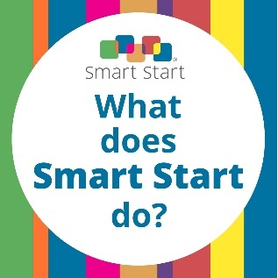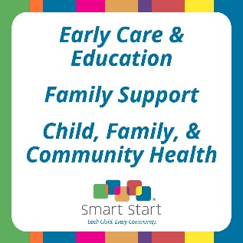
Text:
𝗪𝗵𝗮𝘁 𝗱𝗼𝗲𝘀 𝗦𝗺𝗮𝗿𝘁 𝗦𝘁𝗮𝗿𝘁 𝗱𝗼? Here’s how the Smart Start Network is making a difference across the state:
🍎 Early Care & Education: We work with child care providers to raise the quality of early learning.
👪 Family Support: We partner with families by offering resources and programs that encourage them to discover and lean into their own power.
💪 Child & Family Health: From birth to Kindergarten, we connect our community to services that promote physical, emotional, and mental well-being.
Learn more about our partnership’s work at [YOUR WEBSITE].
Alternate Text for Customization:
𝗪𝗵𝗮𝘁 𝗱𝗼𝗲𝘀 𝗦𝗺𝗮𝗿𝘁 𝗦𝘁𝗮𝗿𝘁 𝗱𝗼? At Smart Start, our mission is to ensure that every child in every community has the support they need to thrive.
Here’s how [PARTNERSHIP NAME] is making a difference in [COUNTY/COUNTIES NAME]
🍎 Early Care & Education: We work with [NUMBER OF CHILD CARE PROVIDERS] child care providers to raise the quality of early learning.
👪 Family Support: We partner with families by providing resources and programs [FAMILY SUPPORT PROGRAMS IN YOUR COMMUNITY] so families can discover and lean into their own power.
💪 Child & Family Health: From pregnancy to pre-k, we connect our community to services that promote physical, emotional, and mental well-being. Services include [LIST OUT SERVICES IN YOUR COMMUNITY].
Learn more about our partnership’s work at [YOUR WEBSITE].

Example 4
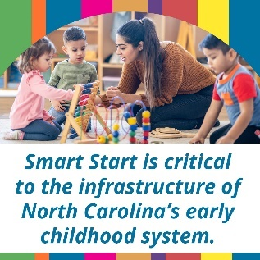
Text:
The Smart Start Network administers state, federal, local, and private programs and services, such as NC Pre-K, child care subsidy, and Head Start, serving as North Carolina’s system for early childhood health, development, and learning.
In [COUNTY], [LOCAL PARTNERSHIP NAME] is a critical part of the early childhood landscape. At [PARTNERSHIP] we implement [LIST YOUR IMPACT AREAS: NC PRE-K, THE HEALTH CARE SYSTEM, ETC] for [NUMBER OF CHILDREN].

Example 5
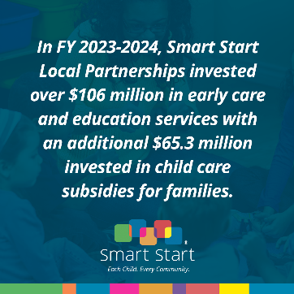
Text:
In FY 2023–2024, Smart Start Local Partnerships invested:
$106 million in early care and education - funding high-quality child care, coaching for teachers, classroom materials, and more
$65.3 million in child care subsidies - helping working families afford the care they need to stay employed and keep their kids safe, learning, and growing

That’s $171 million directly benefiting kids, caregivers, and communities in North Carolina. It means-
✅ More classrooms with trained, supported educators
✅ More families connected to reliable, affordable care
✅ More children being set up for lifelong success

Example 6
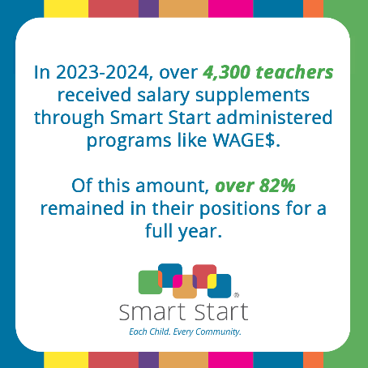
Text:
The Smart Start Network works in every community to provide workforce development to child care center providers. Additional compensation helps stabilize the workforce and retain a qualified workforce.
Note this is a great opportunity for your Local Partnership to share a story of working with child care providers in your community. You can share photos and statistics of your work in your community!

Example 7
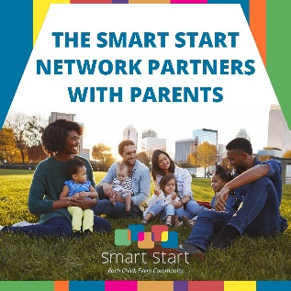
Text:
[LOCAL PARTNERSHIP NAME] believes strong families build strong communities. From parenting programs to early literacy programs, the Smart Start Network partners with families in every community across the state.
🔍 Learn more about how Smart Start is partnering with families to reach their goals in [COUNTY/COUNTIES] at [YOUR WEBSITE].
📌🗺️Find your local Smart Start partnership at https://www.smartstart.org/in-your-community/

Example 8
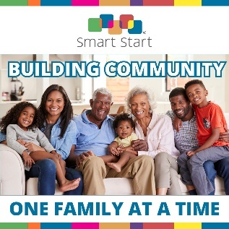
Text:
𝗕𝘂𝗶𝗹𝗱𝗶𝗻𝗴 𝗖𝗼𝗺𝗺𝘂𝗻𝗶𝘁𝘆, 𝗢𝗻𝗲 𝗙𝗮𝗺𝗶𝗹𝘆 𝗮𝘁 𝗮 𝗧𝗶𝗺𝗲!
Smart Start partnerships host community events that bring parents together, creating space for parent-to-parent support that supports parents mentally and emotionally.
At one Partnership, a parent received support from their peers after feeling alone.
“My local Smart Start Partnership is a blessing and I hope that they will be able to continue to reach out to other moms and/or families who may need the support that I am benefiting from and helping me to move forward and plan life with a better, more positive mindset.”
🔍Join our community in [INSERT COUNTY] by visiting [WEBSITE]
Note: If your Local Partnership provides community support, you can replace this story with one of your own!

Example 9

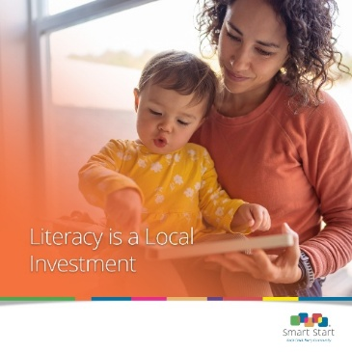

Text:
Learning to read starts early, in the home, long before Kindergarten or even pre-k.

That’s why [LOCAL PARTNERSHIP] invests in early literacy programs that get books into homes at low or no-cost, support reading routines, and help parents feel confident as their child’s first teacher.

Learn about our literacy initiatives at [YOUR WEBSITE].

Alternate ending if you do not have a website: Learn about the Smart Start Network’s commitment to literacy at smartstart.org/expanding-early-literacy/

Example 10
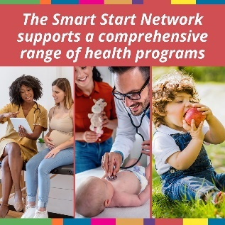
Text:
Smart Start supports a comprehensive range of health programs across North Carolina to benefit families and child care providers.
The programs and strategies we fund improve access to:
👶 Prenatal to newborn services: Ensuring healthy births and babies
🩺 Health Screenings: Early detection and intervention for developmental concerns
🥦 Nutrition Programs: Promoting healthy eating habits for growing children
🦷 Oral Health Care: Providing oral health care support.
👓 Vision Screenings: Partnerships help provide critical early vision screenings.
🔍 Learn more about the programs in [COUNTY/COUNTIES] at [YOUR WEBSITE].

