North Carolina's Action Plan for Building
a Statewide Home Visiting and Parenting Education System
November 2020

Parents play the lead role in their child’s healthy development and growth. But, parents are increasingly stretched and stressed, and most could use support and assistance. Unfortunately, the ability to access parenting support services varies greatly depending on where you live in the state. A patchwork of home visiting services exists across North Carolina and some areas have limited or no services. State and community leaders in North Carolina aim to change that and have crafted a System Action Plan to achieve a shared vision.
Vision:
All families have access to a range of parenting education supports, from the prenatal period to age 8, within a coordinated delivery system, which will positively impact parent-child relationship and family and child well-being.

Development of the System Action Plan was sparked by the 2018 NC Early Home Visiting Landscape Analysis completed by the Jordan Institute for Families at UNC Chapel Hill with support from several North Carolina philanthropic organizations.
Over the last 18 months, more than 40 leaders representing state and local public and private funders, policy and advocacy organizations, and administrators of parenting support programs worked together to develop a System Action Plan fully reflective of the North Carolina context to guide systemic improvement and service expansion over time. The planning work was hosted by NC Partnership for Children (NCPC) in partnership with the N.C. Department of Health and Human Services (DHHS) and UNC Chapel Hill. Find the full Plan here.
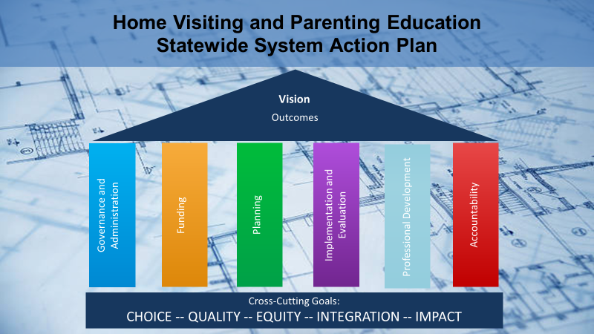

Goals for North Carolina's Home Visiting and Parenting Education System
CHOICE - To advance a continuum of home visiting and parent education models and intensity, with equitable access to families in need and seeking the services.
QUALITY SUPPORTS - To align and coordinate home visiting and parenting education in a manner that maximizes the potential of the workforce and each model, leverages the best of knowledge and supports across the early childhood system, and results in mutually reinforcing activities across models and the system.
RACIAL EQUITY - To build and maintain a system that remediates racial and economic inequities through the equitable access points, quality and distribution of services.
INTEGRATION - To develop a system that will advance home visiting and parenting education while fully integrating home visiting and parenting education as part of the bigger system of early childhood, maternal and child health, and social services in North Carolina.
IMPACT - To develop and operationalize, supporting at a systemic level, strategies that maximize resources, support efficiency in operations, allow for leveraging of model impacts and implementation approaches, and are continuously informed by outcomes for children and families.

What’s Next?
- A collaborative board and subcommittees will be established this Winter to guide implementation of the Plan in accordance with shared values for governance. .
- NCPC will serve as the host agency to support the work of the collaborative board and subcommittees.
- Initial implementation focus will center on the System Action Plan priorities identified by the Planning Team including strategies employed with an equity lens to improve Governance, Funding and Financing, and Assessment and Planning for parenting support services.
- Continuing communication updates on the governance structure and membership, System Action Plan priorities, and the latest information on this initial organizing and implementation

The following Guiding Principles were used for all decision-making during planning and will continue to guide implementation:
- All families need support, a systemic approach to this support must address the structural, or societal, and institutional inequities that exist impacting family awareness, access and engagement.
- A shared understanding of mixed modality delivery of home visiting and parenting education is fostered and resources on implementation and impact of this approach are advanced, with a focus on local context, control and variability.
- All models are represented and heard in the system.
- The work is based in interagency planning and coordination, cross-sector collaboration and mutually reinforcing activities to increase capacity and quality of all home visiting and parent education programs.
- Decisions are informed by a continuous quality improvement approach with access to data on outcomes, results and program impact, and the activities that are designed to impact quality and capacity.
- Each concept, policy or strategy will be analyzed for its impact on promoting equity and aligning and coordinating across programs and will seek and support the linkages and collaborations with the broader birth to five system in NC and the Early Childhood Action Plan.
- The statewide system and leadership advances opportunity for federal, state and local investment in home visiting and parent education.
Find the Complete Home Visiting and Parent Education System Action Plan

The Home Visiting and Parenting Education System planning and implementation work is funded by our generous supporters and partners:
