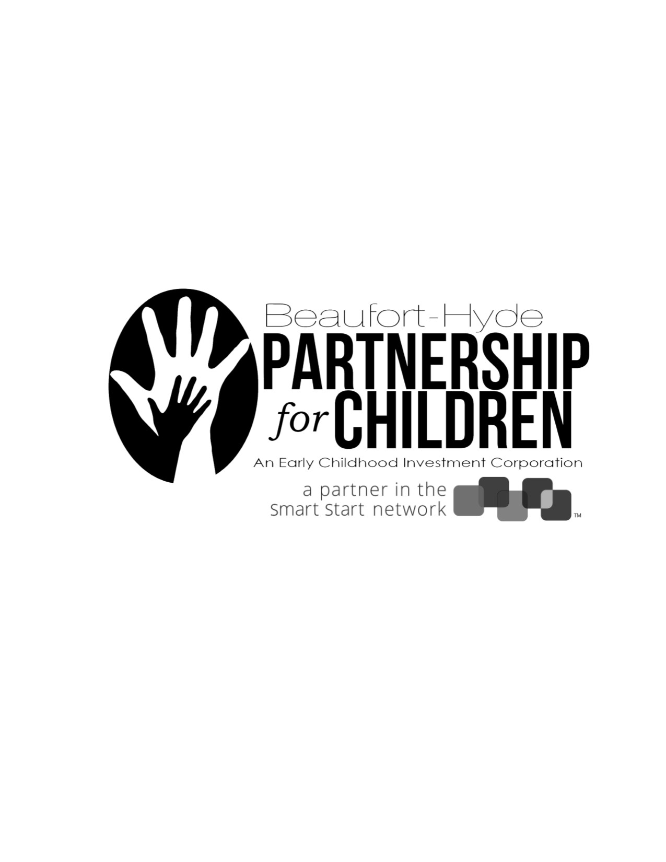
Please complete by July 23, 2019 if you have a child age five or younger living in your household.
Thank you for your time and input.

- What are the ages of the children living with you? (Check all that apply)
0-5 6-12 13-18 19+
- Where do you stay or live? (Select one)

- Aurora
- Bath
- Belhaven

- Blounts Creek
- Chocowinity
- Pantego

- Pinetown
- Washington
- Engelhard

- Fairfield
- Ocracoke
- Scranton
- Swan Quarter

- How long have you been a resident? (Select one)

- Less than one month
- 1 month to 2 years
- 3-6 years
- 7-12 years
- 13+ years

- Current housing status: (Select all that apply)

- Rental
- Own
- "Couch Surfing"
- Alone

- With Roommates
- With Family
- Other (please specify)
_________________________________

- Have you or your family received resources, tools, or services from any of the following
agencies/groups in the past year? (Select all that apply)

- AA Meetings
- Beaufort-Hyde Partnership for Children
- Boys & Girls Club
- Coastal Pregnancy Center
- County Court System
- County Health Department
- County Social Services Department
- Child Developmental Service Agency
- Eagles Wings
- Food Backpack (Summer Feeding Program)
- Holiday Meal/Baskets
- Hyde County Hotline
- Library (BHM and Brown Library)

- Mental Health Services
- Martha’s Project Food Pantry
- Open Door Community Center
- Ruth’s House (Domestic Violence Center)
- Salvation Army
- Shop with a Cop
- Veteran Services
- Vidant
- Zion Shelter and Kitchen
- Church
- Not Applicable
- Other: (please specify the name of group/organization and how they helped)
_________________________________

6. What are some barriers and challenges that keep you from accessing community resources, tools or
services? (Select all that apply)
- Transportation
- Language (for example: I needed an interpreter or materials interpreted)
- Felt I Was Not Understood
- Felt My Concerns Were Not Heard
- Felt Judged
- Did Not Feel Welcomed
- No Knowledge of Existing Program
- Time When Resources are Available
- Lack of Child Care
- Did Not Want Others to Know I am in Need of Resource(s)
- Other: __________________________________________ (please turn over)

7. What are the top 3 resources, tools, or services you or your family could use or benefit from now or in the near future? (Check 3 boxes)

- Employment opportunities
- Job Skills
- Resume Help
- Childcare
- GED Opportunities
- Parenting Classes
- English Language Classes
- Health Care
- Help with Adult Reading
- Housing
- Home Repairs
- Rent Assistance/Reduction
- Overnight Shelter
- Help in Getting Information About Other Agencies
- Laundry
- Toiletries/Cleaning Supplies

- Support for Family’s and/or My Needs to be Met
- Electricity Assistance
- Water Sewer Assistance
- Heat/Propane
- Heat/Wood
- Support with Experiencing Trauma
- Help in Finding Support Groups
- Support in Having My Voice Heard in the Community
- Clothing
- Phone Internet Access
- Hot Meals
- Food Pantry
- Other (Please specify) :
_____________________________
_____________________________

8. What are the two biggest stresses facing your family?
1.___________________________________________________________________________
2. __________________________________________________________________________

9. When you have a need related to supporting and caring for your children and family, where do you go
for information and support? (Select all that apply)

- Other Family Members
- Friends
- Church
- County Department of Social Services
- County Health Department
- Counselors
- Facebook, Instagram, Twitter, Snapchat, etc. and other Social Media
- Internet or Website Search
- Child Care/Schools
- Doctors’ Offices
- Barber Shops/Salons
- Community Organizations (i.e.: Salvation Army, Coastal Pregnancy Center, etc.)
- Beaufort-Hyde Partnership for Children
- Other (Please specify): _______________________________ _______________________________

10. How and where do you connect with resources, tools, or services in the community that help your family? (Select all that apply)

- TV
- Radio
- Internet Search
- Email
- Facebook, Twitter, etc. and Other Social Media
- Billboards
- Fliers and Brochures
- Newspapers
- Newsletters
- Referrals to Other Agencies
- Other (Please specify): _______________________________ _______________________________

Thank you!
Please return to Jewell Gardner at the Beaufort-Hyde Partnership for Children by July 23, 2019.
979 Washington Square Mall, Washington, NC 27889 252-975-4647, ext. 19 jewell@bhckids.org

