Twitter Templates:
- Smart Start partners with Dolly Parton’s Imagination Library to bring books to young children in NC. RT if you’re excited about registering your child. #imaginationlibrary #dollyslibrary
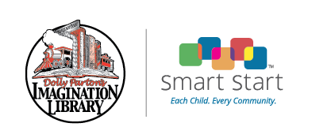

- Check your child’s eligibility to receive a free book each month from Smart Start and @Dollyslibrary http://www.smartstart.org/dolly-partons-imagination-library/registration-dolly-partons-imagination-library/

- Thanks to @SenRalphHise, Rep Dobson, and Rep Burr, Smart Start has partnered with @Dollyslibrary. #dollyslibary #readmore

- @DollyParton welcomes NC to @Dollyslibrary with a new partnership between Smart Start and the Dolly Parton’s Imagination Library. #dollyslibrary #readmore #booklady (Link to Dolly Parton video).

