Template Facebook Posts:
Facebook Posts for the October 20th Launch:
- Smart Start and Dolly Parton’s Imagination Library launch statewide effort to bring books to North Carolina’s youngest children. Visit http://www.smartstart.org/dolly-partons-imagination-library/ to learn more.

- Thanks @SenRalphHise, Representative Dobson, and Representative Justin Burr for helping Smart Start bring books directly into the homes of North Carolina’s youngest children.

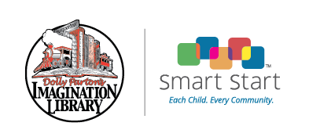

- Dolly Parton welcomes NC to a new partnership between Smart Start and Dolly Parton’s Imagination Library. (Insert link to Dolly Parton’s welcome video)

- Check book availability for Dolly Parton’s Imagination Library for your area and register your child today at http://www.smartstart.org/dolly-partons-imagination-library/registration-dolly-partons-imagination-library/

